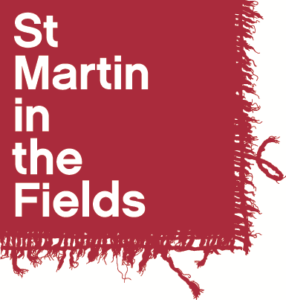

St Martin-in-the-Fields

Choral Scholarship 2025-26

Application Form

Name: ……………………………………………………………………

Voice Part: Soprano / Alto / Tenor / Bass

- Personal Details

Full Name: | Contact Telephone Number(s):
Preferred pronouns e.g. she/her: | Email:
Contact Address:

- References

If you are shortlisted for an audition, we may wish to take up references. You should give the name of one musical referee who has experience of your singing and one other referee who can give us a character reference.

First Referee
Name:
Position:
Relationship to you:
Address:

Telephone Number:
Email address:
May we contact this referee prior to interview? Yes No

Second Referee
Name:
Position:
Relationship to you:
Address:

Telephone Number:
Email address:
May we contact this referee prior to interview? Yes No

- Education

Schools, Colleges, Universities or Institutes of Further Education attended (including part time) | Dates |  | Qualifications gained
 | From | To

- Please answer the following questions

Your answers will provide the basis for some discussion in the interview.
- Why are you applying for a Choral Scholarship at St Martin’s?
- What do you plan to be doing alongside the scholarship (e.g. university / college course; gap year etc) and how do you see this arrangement working in terms of compatibility and time management?

- How would the scholarship fit in with your plans for the future?

- Declaration

I certify that the information I have provided on this application form is correct and agree that the information given can be used as a basis for some discussion in the scholarship interview.

Signed: ………………………………………………………………….. Date: ………………………………

- Audition Dates

Auditions will take place during one of the time slots below. Please could you let us know in the table if there are any times you will be unavailable / comments about your availability during the slot.

Audition Time Slots | Availability Comments
Monday 5th May, 2-5pm
Thursday 8th May, 5-7pm
Sunday 11th May, 11.30-2pm

Please complete the application form and send, along with a current CV, by email to Alicia Hinchliffe, Music Programme Manager at alicia.hinchliffe@smitf.org by Tuesday 22nd April at the latest.

