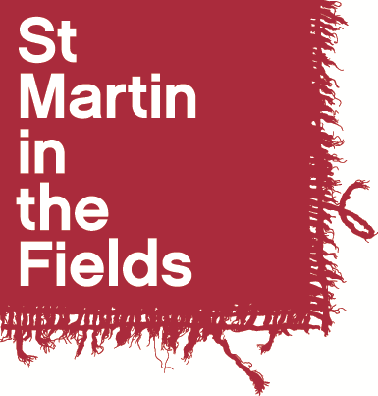

Associate Choral Leader
St Gregory’s, Sudbury with St Martin-in-the-Fields

Application Form

Name: ……………………………………………………………………

- Personal Details

First Name(s): | Contact Telephone Number(s):
Surname: | Email:
Contact Address:

- References

If you are shortlisted for an audition, we may wish to take up references. You should give the name of one musical referee and one other referee who can give us a character reference.

First Referee
Name:
Position:
Relationship to you:
Address:

Telephone Number:
Email address:
May we contact this referee prior to interview? Yes □ No □

Second Referee
Name:
Position:
Relationship to you:
Address:

Telephone Number:
Email address:
May we contact this referee prior to interview? Yes □ No □

- Education

Schools, Colleges, Universities or Institutes of Further Education attended (including part time) | Dates |  | Qualifications gained
 | From | To | Qualifications gained

- Please answer the following questions

Your answers will provide the basis for some discussion in the interview.
- Why are you applying for the Associate Choral Leadership programme?
- Tell us about your experience in choral conducting and/or vocal leading, and comment in particular on any experience you have in leading children’s choir’s and adult community choirs
- What else do you plan to be doing alongside the Associate Choral Leadership and how do you see this arrangement working in terms of compatibility and time management?

- Declaration

I certify that the information I have provided on this application form is correct and agree that the information given can be used as a basis for some discussion in the choral leadership interview.

Signed: ………………………………………………………………….. Date: ………………………………

- Audition Dates

Auditions will take place in the week commencing Monday 23rd September. Please could you let us know in the table if there are any times you will be unavailable / comments about your availability.

Please return this form, along with a current CV, by email to Phoebe Palmer at choirs@smitf.org by Friday 13th September at 12 noon.

